1. What are three conclusions we can make about Kickstarter campaigns given the provided data?
   1. More Kickstarter projects are created for Theater category

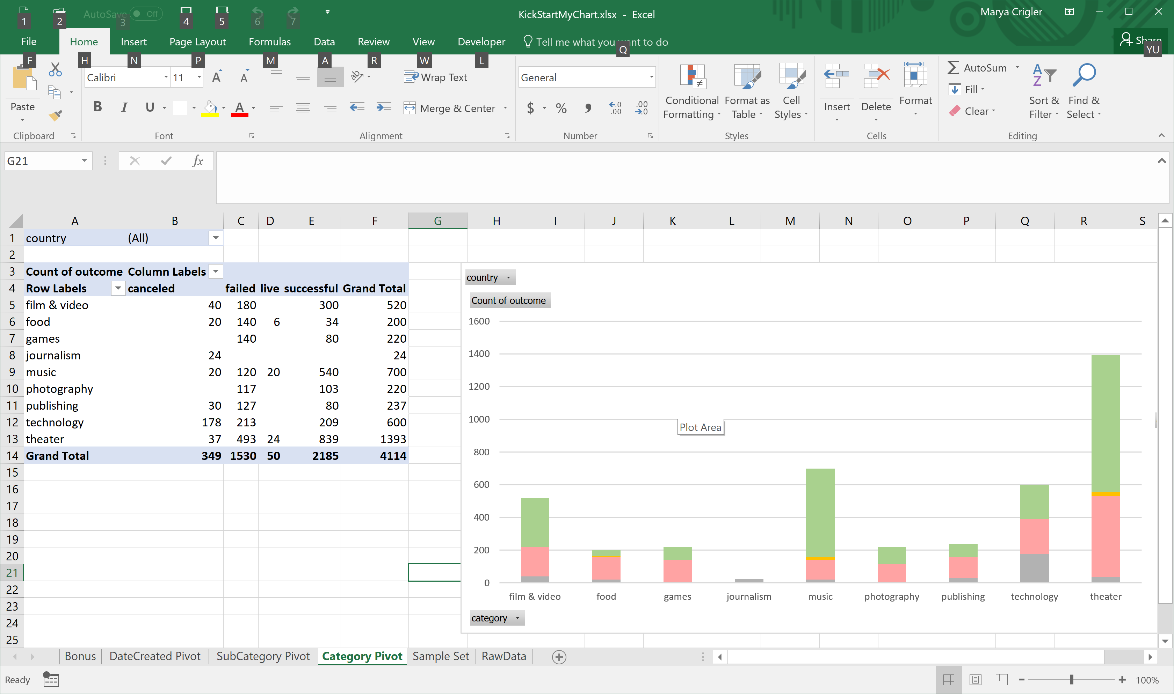

* 1. Theater projects are more often plays than musicals

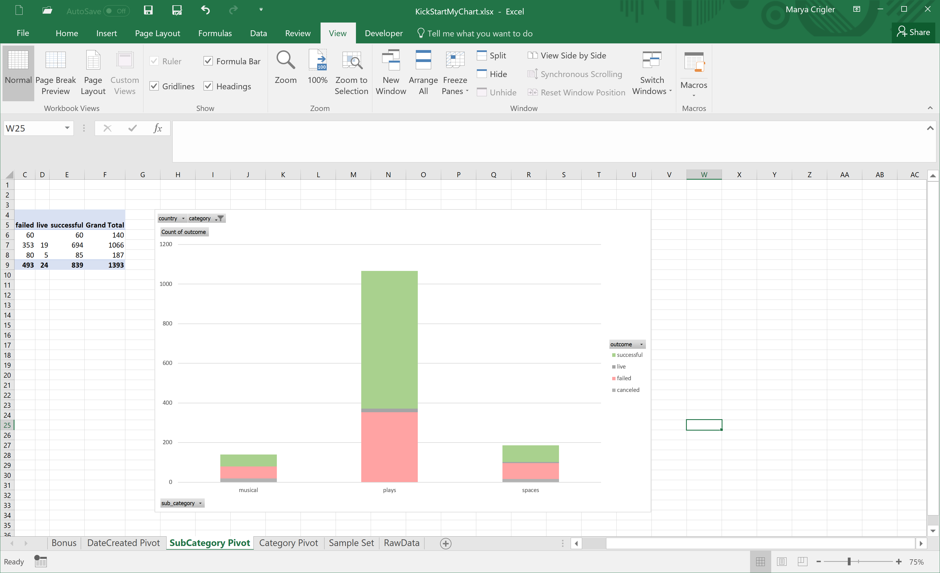

* 1. In the Music category, Rock project have a high probability of success.

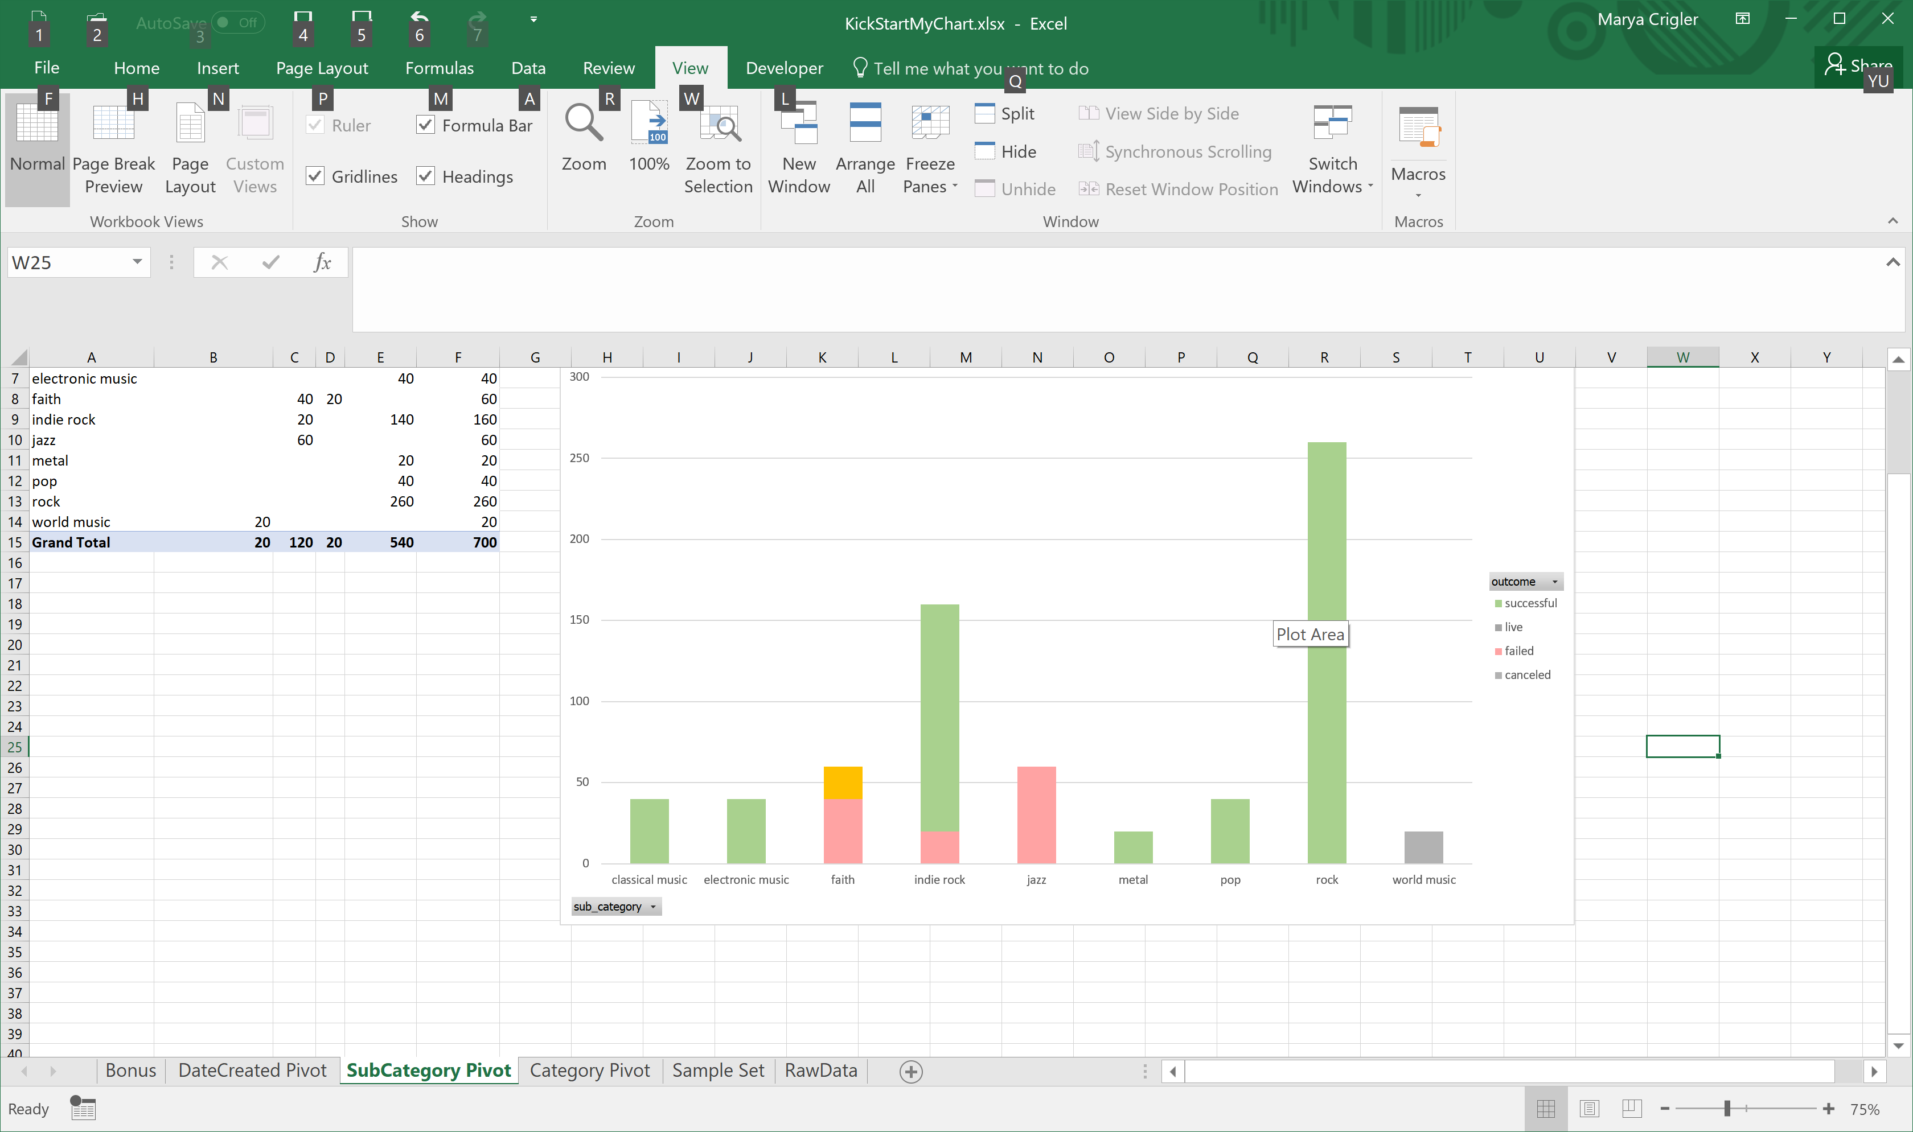

* 1. The best time to start a project is May and the worst is December.

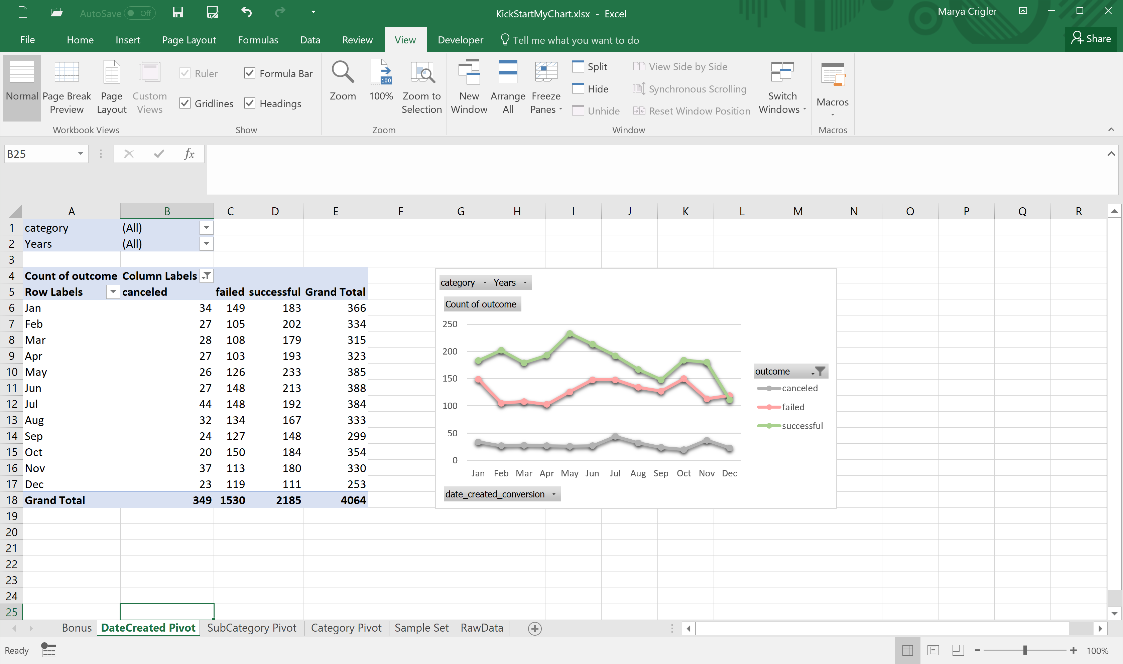

1. What are some of the limitations of this dataset?
   1. Average donation could be skewed by one high dollar donor; however we lack sufficient data to calculate a median donation
   2. Who is behind the project could be a driver of project success and that data is missing from the data set.
2. What are some other possible tables/graphs that we could create?
   1. Percent funding by project category and sub category
   2. Outcomes by number of days from launch to deadline